System LSI

Reed Solomon IP
CoreProgram
Version 1.0

For OpenCores
2011 July 26

Copyright (C) 2011 System LSI CO., LTD http://www.syslsi.com/

This program is free software: you can redistribute it and/or modify
it under the terms of the GNU General Public License as published by
the Free Software Foundation, either version 3 of the License, or any later version.
This program is distributed in the hope that it will be useful,
but WITHOUT ANY WARRANTY; without even the implied warranty of
MERCHANTABILITY or FITNESS FOR A PARTICULAR PURPOSE. See the
GNU General Public License for more details.
You should have received a copy of the GNU General Public License
along with this program. If not, see <http://www.gnu.org/licenses/>.

History
Ver. | YYYY/MM/DD | Author | Comment
1.0 | 2011/07/26 | Kazunari Hayashi | 1st Create

Contents

History 2
Contents 3
1. Reed Solomon Function 4
1.1 General Description 4
1.2 Parameter Requirement 5
2. IP CoreProgram 6
2.1 Environment 6
2.2 Program Files 7
2.3 Program Hierarchy 8
3. Verilog-RTL Modules 10
3.1 Encoder 10
3.2 Decoder 11
3.3 Implementation 13

1. Reed Solomon Function

  - General Description

This tool is used to generate Reed Solomon IP which includes Encoder/Decoder RTL and testbench.
Basically Reed Solomon uses unit of symbol by ‘r’ bits. One block consists of N symbols. N symbols called code symbols includs K symbols of Source and (N-K) symbols of Redundancy. (c.f. Fig.1-1)

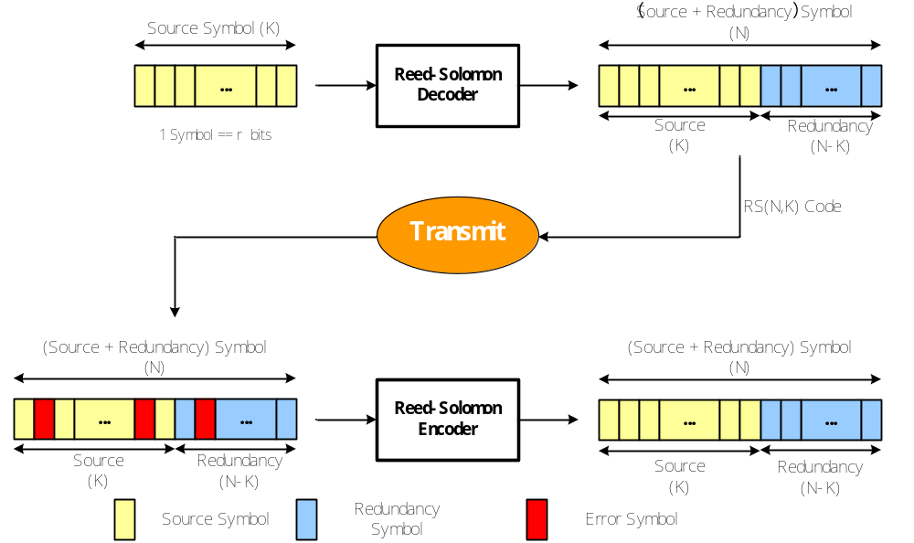
Fig.1-1 Reed Solomon System Block
  - Parameter Requirement
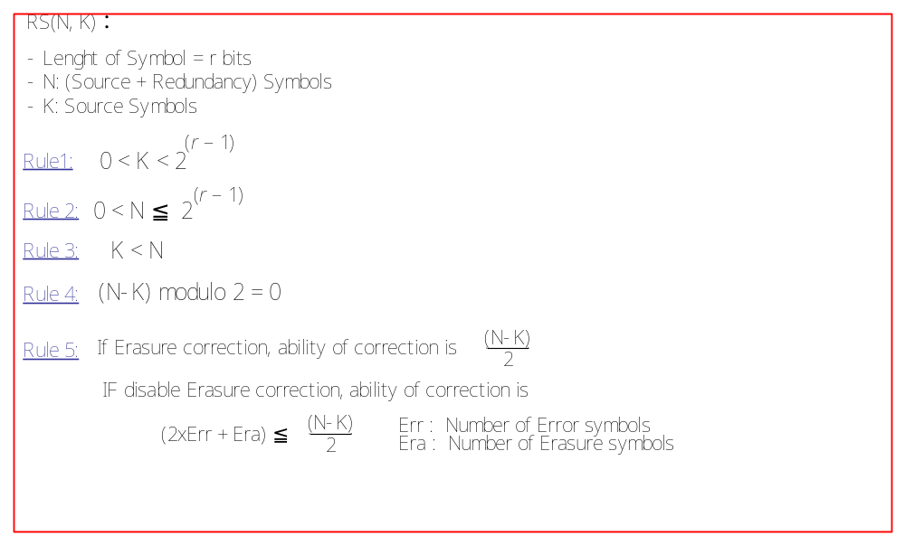
Fig.1-2 Parameter Requirement

- IP CoreProgram
  - Environment

The working of this tool is confirmed on command prompt of Windows XP.
Already confirmed compilers are:
- Microsoft Visual Studio .NET 2003
- Microsoft Visual C++ 2008 Express Edition
- Microsoft Visual Studio 2010 Express Edition

There are many options when the command is invoked.

DataSize = atoi(argv[1]); // Source Symbol K, range = [1..(2^r)-3]
TotalSize = atoi(argv[2]); // Total Symbol N, range = [3..(2^r)-1]
PrimPoly = atoi(argv[3]); // Primitive Polynomial
ErasureOption = atoi(argv[4]); // Erasure Decoding (0: No, 1:Yes)
BlockAmount = atoi(argv[5]); // [sim]RS Decoder Block Amount
ErrorRate = atoi(argv[6]); // [sim]Error rate, range = [0..99]
PowerErrorRate = atoi(argv[7]); // [sim]Power of Error Rate (0: 1, 1: 10^-1, 4: 10^-4)
ErasureRate = atoi(argv[8]); // [sim]Erasure rate, range = [0..99]
PowerErasureRate = atoi(argv[9]); // [sim]Power of Error Rate (0: 1, 1: 10^-1, 4: 10^-4)
bitSymbol = atoi(argv[10]); // bit of Symbol, range = [3..12]
errorStats = atoi(argv[11]); // Error Status (0: No, 1:Yes)
passFailFlag = atoi(argv[12]); // Pass/Fail Flag (0: No, 1:Yes)
delayDataIn = atoi(argv[13]); // Delayed Data (0: No, 1:Yes)
encDecMode = atoi(argv[14]); // Select Mode (1: enc only, 2:dec only, 3: enc & dec)
encBlockAmount = atoi(argv[15]); // encoder block amount
ipCustomerKey = atoi(argv[16]); // Revision ID=27

Example: in MS Command Prompt
> RsIpEngine.exe 233 255 285 1 10 25 2 3 0 8 1 1 1 3 3 27

  - Program Files
Table2-1 Description of Program Files
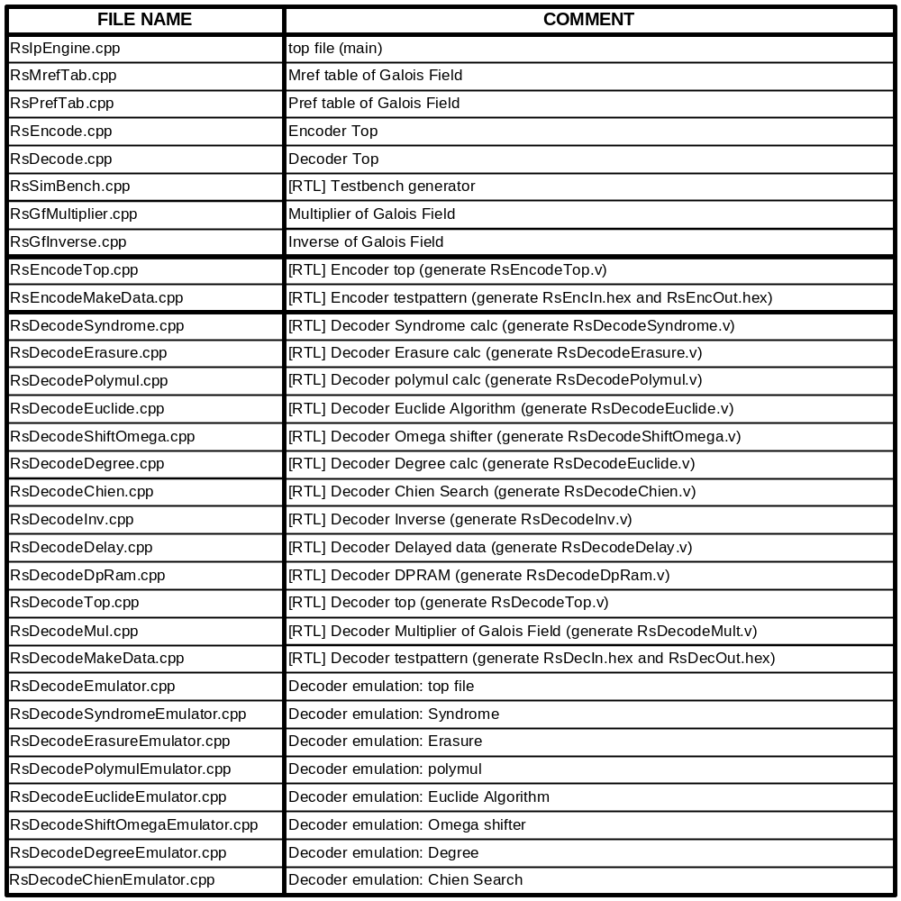

  - Program Hierarchy

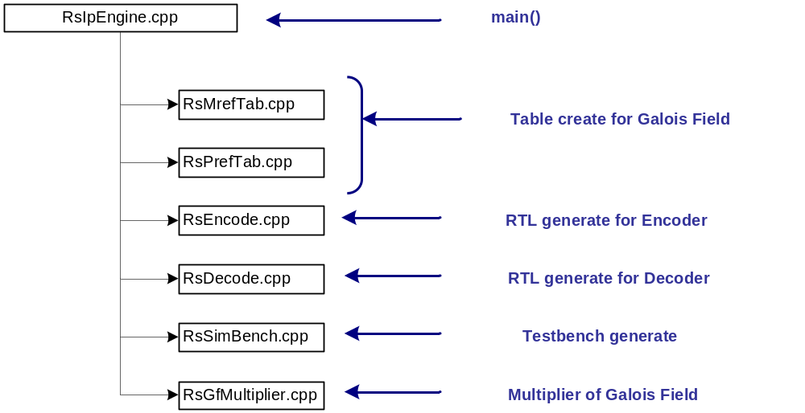
Fig.3-1 TOP structure

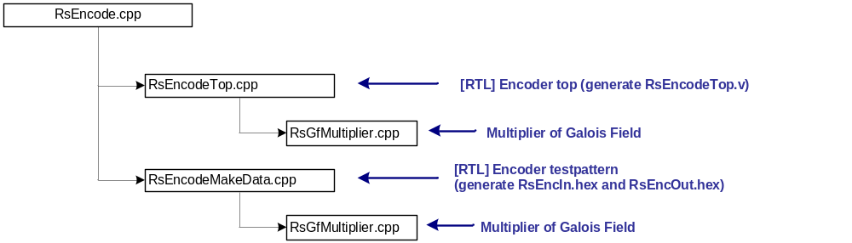
Fig.3-2 RsEncode structure

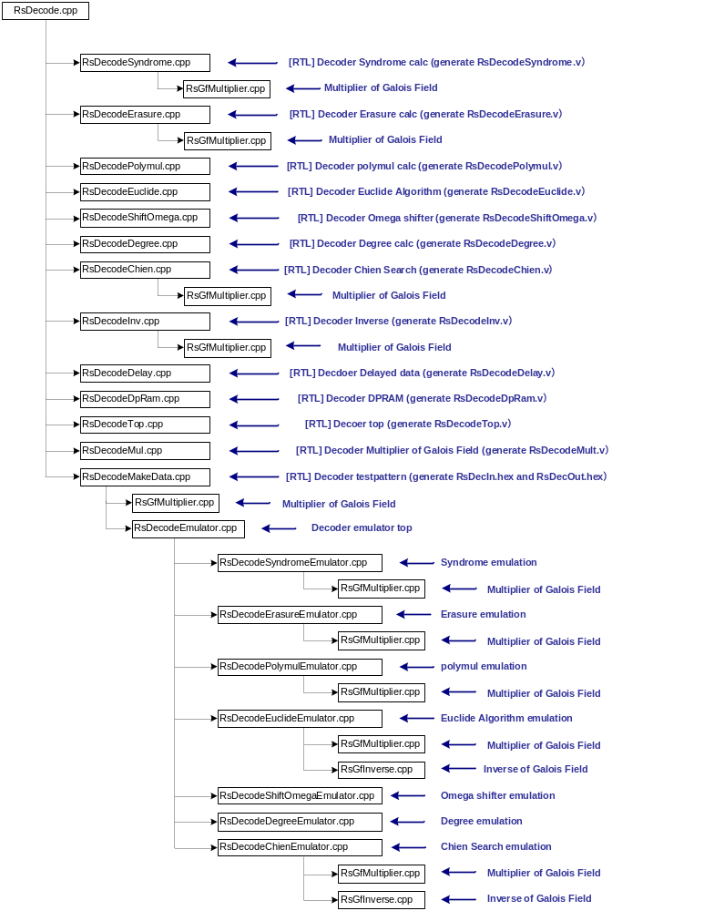
Fig.3-3 RsDecode structure
- Verilog-RTL Modules
  - Encoder
Table 3-1 Encoder Module I/O
Signal Name | I/O | Comment
CLK | 入力 | system clock (Active on rising edge)
RESET | 入力 | Async. reset (Active on negative)
enable | 入力 | system enable（Active Hi)
startPls | 入力 | Start pulse
dataIn [r-1:0] | 入力 | Source data
dataOut [r-1:0] | 出力 | Encoded data

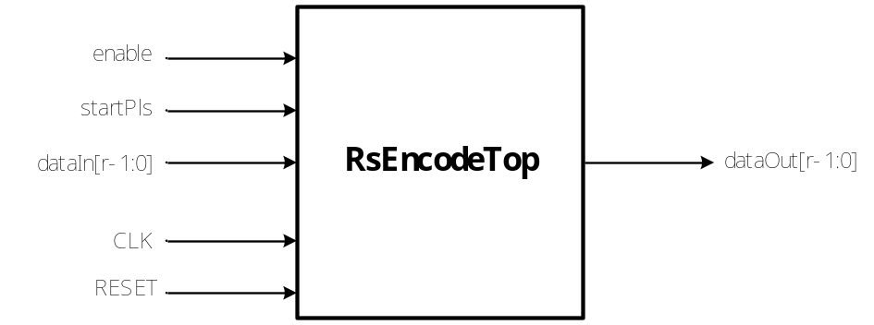
Fig.3-1 Encoder I/F

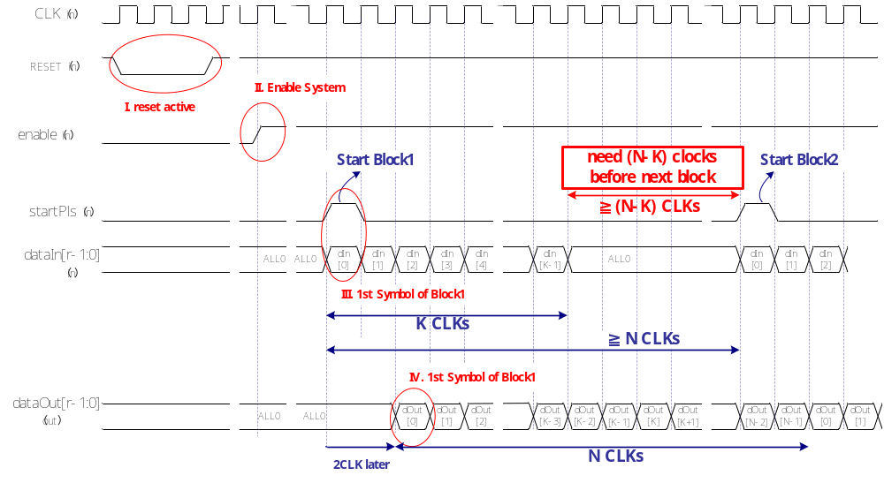
Fig.3-2 Encoder Waveform
  - Decoder

Table 3-2 Decoder Module I/O
Signal Name | Option | I/O | Comment
CLK | No | 入力 | system clock (Active on rising edge)
RESET | No | 入力 | Async. reset (Active on negative)
enable | No | 入力 | system enable（Active Hi)
startPls | No | 入力 | Start pulse
dataIn [r-1:0] | No | 入力 | Encoded data
outDdata [r-1:0] | No | 出力 | Decoded data
outEnable | No | 出力 | Enable of Decoded data
outStartPls | No | 出力 | Start pulse to Decoded data
Outdone | No | 出力 | Indicator of last data
erasureIn | Option | 入力 | Erasure (0:disable 1:enable)
Fail | Option | 出力 | Decode result (0:success 1:fail)
errorNum[r-1:0] | Option | 出力 | number of correction if Fail=0
erasureNum[r-1:0] | Option | 出力 | number of erasure if Fail=0
delayedData[r-1:0] | Option | 出力 | mirror of Encoded data

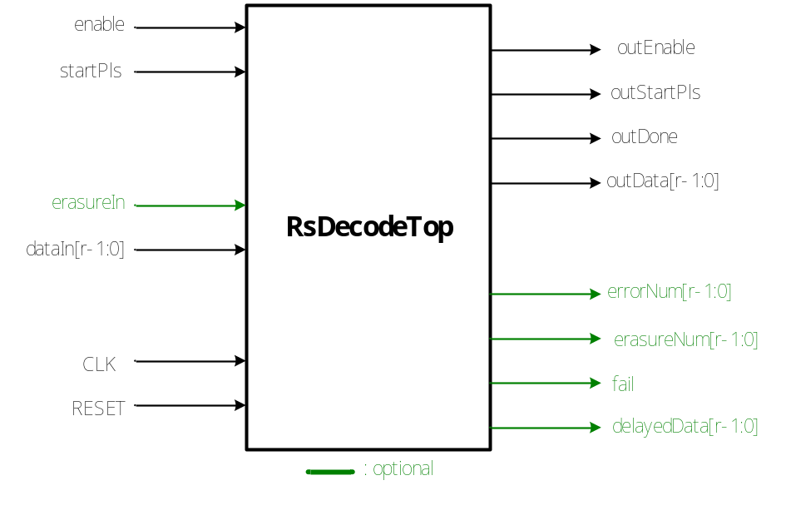
Fig.3-3 Decoder I/F
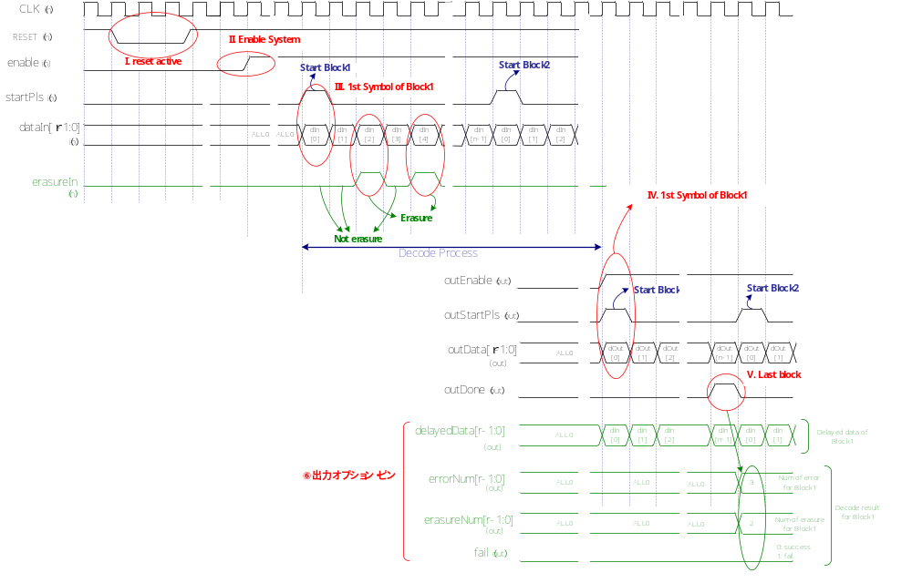 Fig.3-4 Decoder Waveform
  - Implementation

Table 3-3 Encoder implementation for FPGA
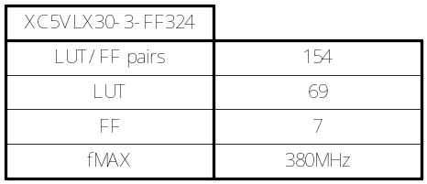

Table 3-4 Decoder implementation for FPGA
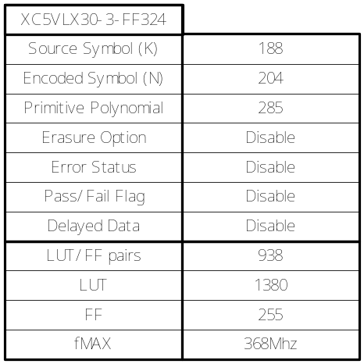

Table 3-5 Code Coverage of Encoder
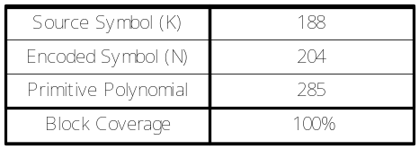

Table 3-6 Code Coverage of Decoder
